Supporting information
Table S1. Compact neoantigen summary for MB49 and 4T1 vaccine constructs.
ID | Tumor Model | Genomic Position | Gene | RNA reads supporting variant allele | RNA reads supporting reference allele | AA change | Sequence | Epitope sequence | MHC Allele | WT sequence | ELISPOT validation status
4T1#1 | 4T1 | chr18:g.31827321C>T | Wdr33 | 43 | 66 | p.H13Y | MATEIGSPPRFF_Y_MPRFQHQAPRQL | GSPPRFFYM | H-2-Dd | GSPPRFFHM | n.s.
4T1#2 | 4T1 | chrX:g.85711101T>C | Gk | 34 | 42 | p.K511R | AEESEIRYSTWK_R_AVMKSIGWVTTQ | RYSTWKRAV | H-2-Kd | RYSTWKKAV | Significant (p<0.0001)
4T1#3 | 4T1 | chr5:g.151045164C>G | Stard13 | 3 | 22 | p.Q1017H | FVQWKVVERLDKQTEIY_H_YVLNSMV | IYHYVLNSM | H-2-Kd | IYQYVLNSM | Significant (p<0.0001)
4T1#4 | 4T1 | chr10:g.119213632T>G | Cand1 | 21 | 109 | p.K403T | REENVKADVFHAYLSLL_T_QTCPVQS | AYLSLLTQT | H-2-Kd | AYLSLLKQT | n.s.
4T1#5 | 4T1 | chr5:g.36824144C>T | Man2b2 | 17 | 70 | p.V210I | SPSLSGQQEIFTH_I_MDHYSYCTPSH | GQQEIFTHI | H-2-Kd | GQQEIFTHV | Significant (p<0.0001)
4T1#6 | 4T1 | chr17:g.43453098G>A | Adgrf5 | 3 | 136 | p.V1304M | GSSTP_M_FSMSSPISRRFNNLFGK | PMFSMSSPI | H-2-Kd | PVFSMSSPI | n.s.
4T1#7 | 4T1 | chr17:g.56211643C>T | Dpp9 | 11 | 61 | p.D54N | RKSSGLIVSKAPH_N_FQFVQKPDESG | KAPHNFQFV | H-2-Dd | KAPHDFQFV | n.s.
4T1#8 | 4T1 | chr16:g.94451047C>T | Ttc3 | 8 | 89 | p.L1533F | TEENKISKTELDWF_F_QDLDREIKKW | FFQDLDREI | H-2-Kd | FLQDLDREI | Significant (p=0.0005)
4T1#9 | 4T1 | chr11:g.100695233C>A | Dhx58 | 66 | 39 | p.R654L | LETPRGKIQAKKWS_L_VPFSIPVFDI | KWSLVPFSI | H-2-Kd | KWSRVPFSI | Significant (p=0.0001)
4T1#10 | 4T1 | chr7:g.24472004G>A | Plaur | 28 | 357 | p.R140H | RGREQSLQC_H_YPTEHCIEVVTLQST | CHYPTEHCI | H-2-Kd | CRYPTEHCI | Significant (p<0.0001)
4T1#11 | 4T1 | chr6:g.135078913C>A | Gprc5a | 53 | 56 | p.F119L | FSCLLAHA_L_NLIKLVRGRKPLSWLV | AHALNLIKL | H-2-Kd | AHAFNLIKL | Significant (p=0.0002)
4T1#12 | 4T1 | chr19:g.47898131G>C | Itprip | 43 | 48 | p.A15G | MELFRVCLVVVT_G_IINHPLLFPREN | TGIINHPLL | H-2-Dd | TAIINHPLL | Significant (p<0.0001)
4T1#13 | 4T1 | chr15:g.12150180A>C | Zfr | 43 | 84 | p.K411T | ADAYAAHIRGAKHQKVV_T_LHTKLGK | KVVTLHTKL | H-2-Kd | KVVKLHTKL | Significant (p<0.0001)
4T1#14 | 4T1 | chr7:g.44535941G>C | Pold1 | 10 | 80 | p.A745G | VESKYTVENGYD_G_NAKVVYGDTDSV | GYDGNAKVV | H-2-Kd | GYDANAKVV | Significant (p<0.0001)
MB49 neoantigen | MB49 | chr8:g.116993366T>C | Gcsh | 154 | 0 | p.T21A | SLRVVAYSLRTAL_A_FCSPRPCVPSAAA | YSLRTALAF | H-2-Kb | YSLRTALTF | Significant (p<0.0001)

Table S2. Consolidated physicochemical characterization of SaPAC/SaPN nanoparticles.
Construct | Peptide concentration | Buffer/condition | Method | Median of hydrodynamic diameter ( +/- sem) | Zeta potential (+/- sem) | TEM morphology | Independent batches
SaPN-OVA | 30 μg/mL | Milli Q water | TEM; NTA/ZetaView | 135 +/- 7 nm | 23.59 +/- 0.48 mV | Nanoparticles | 5
SaPAC-OVA | 5 μg/mL | Milli Q water | TEM; NTA/ZetaView | 169 +/- 18 nm | 28.92 +/- 0.89 mV | Nanoparticles | 5
SaPAC(ii)-OVA | 5 μg/mL | Milli Q water | TEM; NTA/ZetaView | 125 +/- 4 nm | 29.89 +/- 1.64 mV | Nanoparticles | 5
SaPAC(iii)-OVA | 5 μg/mL | Milli Q water | TEM; NTA/ZetaView | 133 +/- 3 nm | 30.71 +/- 1.25 mV | Nanoparticles | 5
SaPAC-MB49 | 30 μg/mL | Milli Q water | TEM; NTA/ZetaView | 169 +/- 4 nm | 14.56 +/- 0.70 mV | Nanoparticles | 3
SaPAC-4T1#2 | 10 μg/mL | Milli Q water | TEM; NTA/ZetaView | 125 +/- 16 nm | 37.66 +/- 0.22 mV | Nanoparticles | 3
SaPAC-4T1#3 | 30 μg/mL | Milli Q water | TEM; NTA/ZetaView | 144 +/- 4 nm | 32.28 +/- 0.86 mV | Nanoparticles | 3
SaPAC-4T1#13 | 30 μg/mL | Milli Q water | TEM; NTA/ZetaView | 116 +/- 2 nm | 31.56 +/- 0.47 mV | Nanoparticles | 3
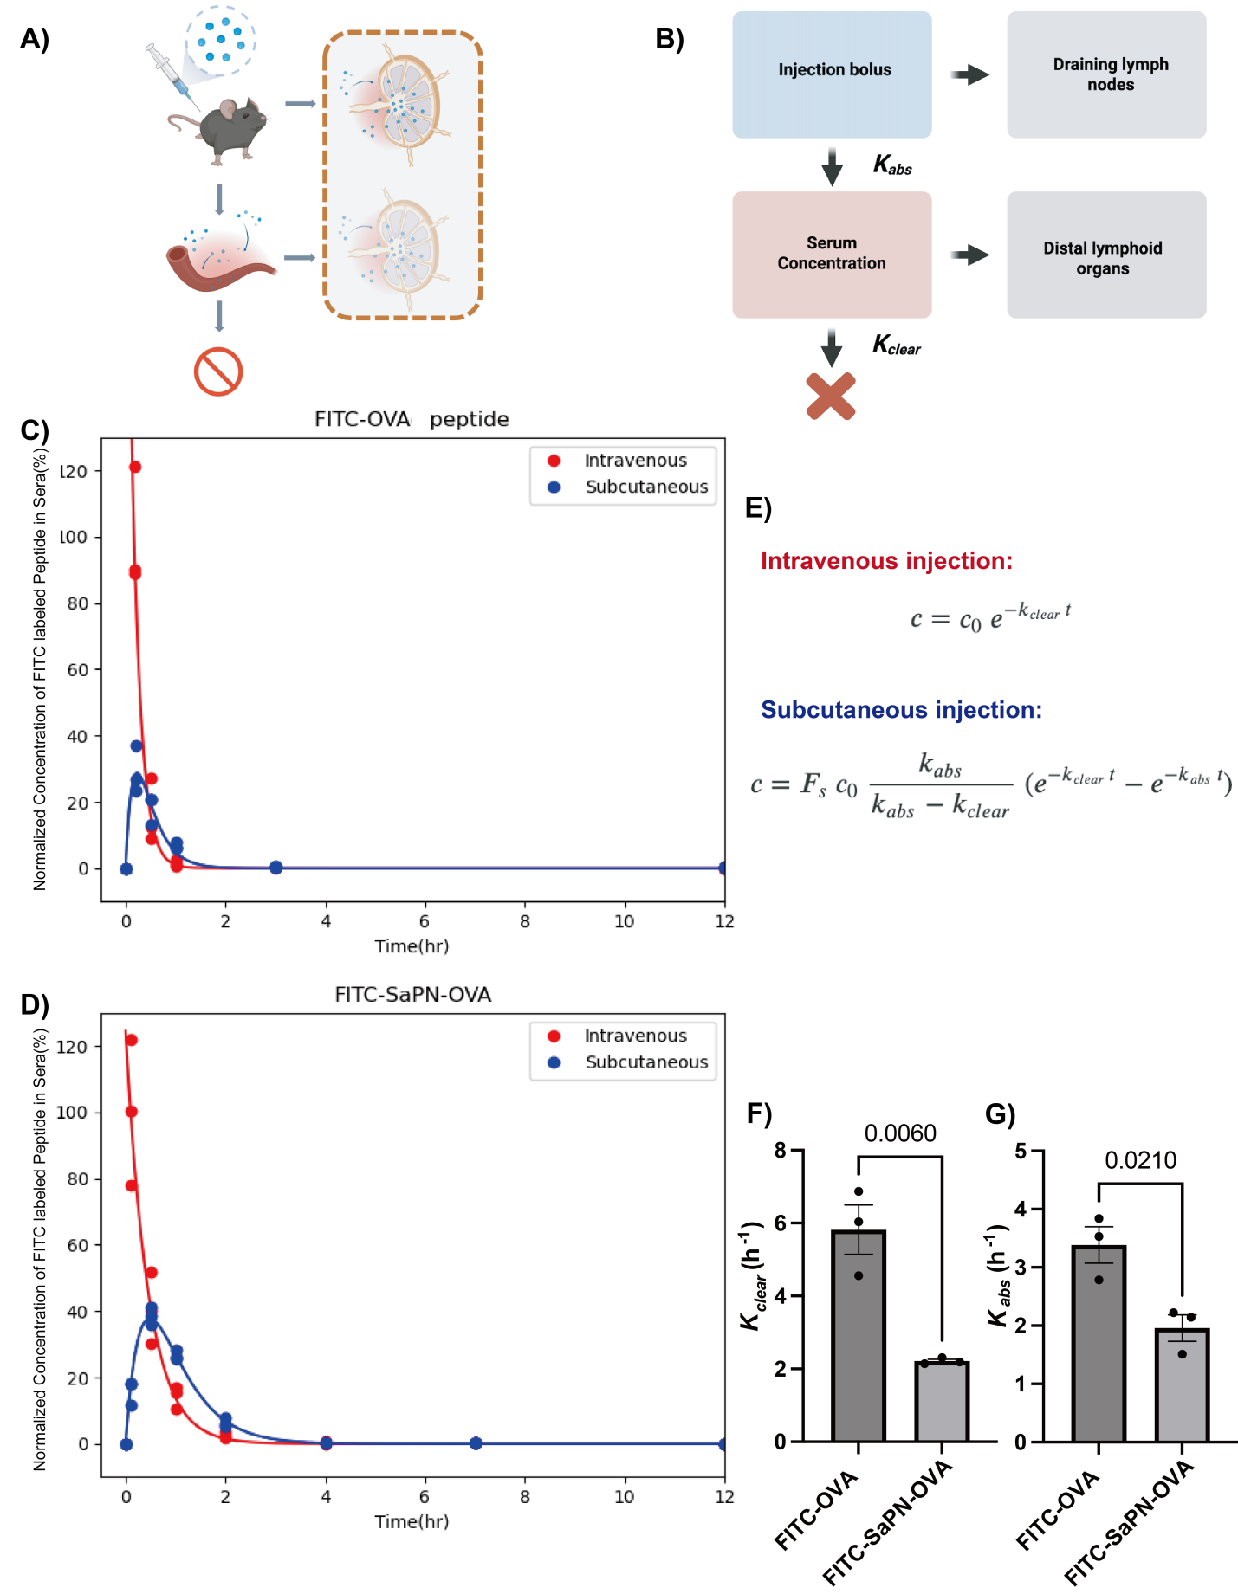
Figure S1. The SaPN platform enhances antigen depot effect and pharmacokinetic exposure. (A,B) Pharmacokinetic model describing absorption and clearance rates that influence peptide antigen bioavailability in lymphoid organs. (C,D) FITC-SaPN-OVA and FITC-OVA serum fluorescence after subcutaneous or intravenous injection. (E) Fitting equations and representative fitted curves generated using SciPy in Python 3.8. (F,G) Calculated clearance and absorption rates.

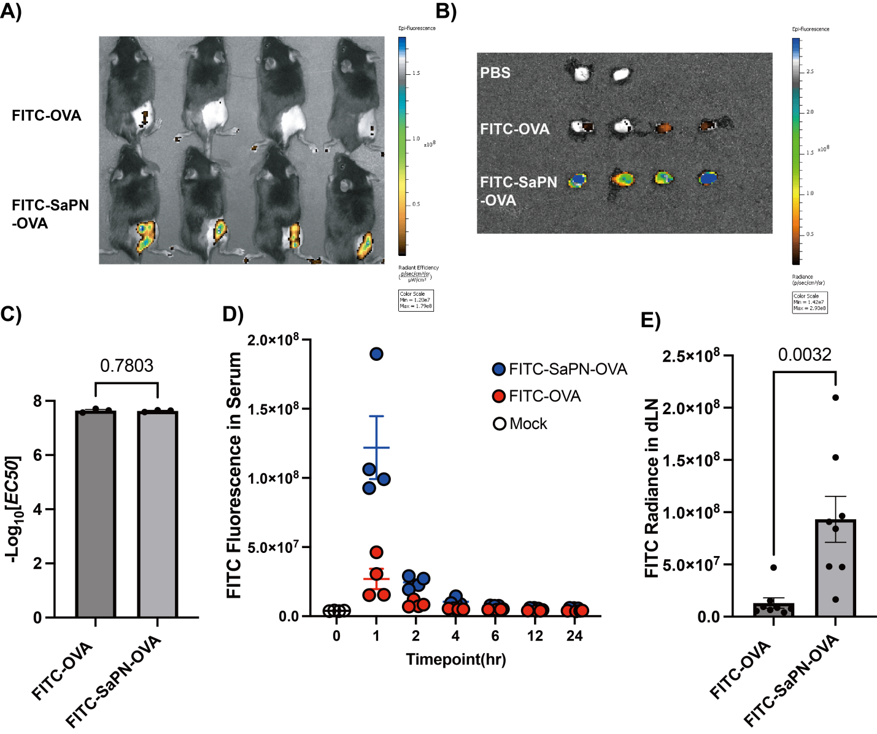

Figure S2. SaPN enhances peptide antigen depot retention and lymphoid-organ bioavailability. (A) Whole-body IVIS fluorescence 6 h after subcutaneous injection. (B) IVIS fluorescence of excised inguinal LNs 6 h post-injection. (C) EC50 fluorescence calibration. (D) Serum fluorescence over 24 h after subcutaneous injection. (E) Quantification of inguinal draining LN fluorescence. Significance was assessed by unpaired two-tailed Student's t-test.
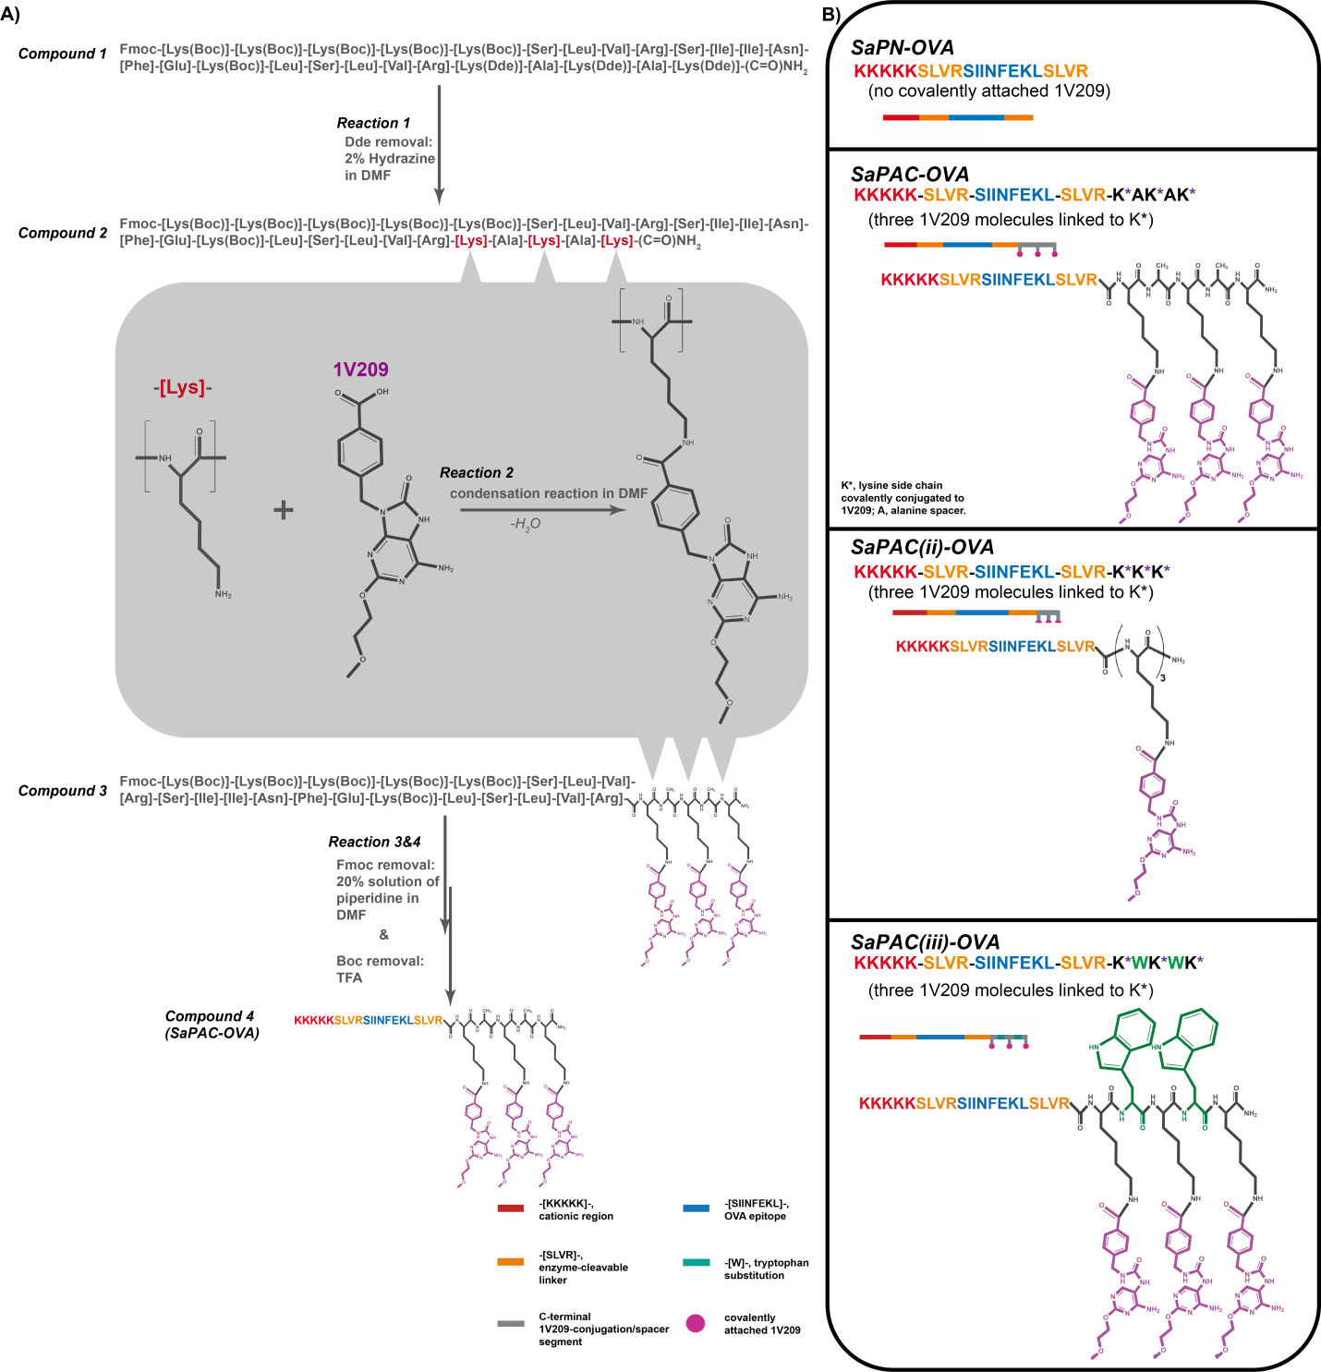
Figure S3. Site-selective synthesis and construct map of SaPAC-OVA variants. (A) The protected peptide precursor (Compound 1) on Rink amide resin contains Boc-protected non-target lysines and Dde-protected target lysines. Selective Dde removal with 2% hydrazine in N,N-dimethylformamide exposes the designated lysine epsilon-amines for coupling of carboxylic-acid-functionalized 1V209. Global Fmoc/Boc deprotection and resin cleavage yield the final SaPAC-OVA conjugate. (B) Construct map of SaPN-OVA, SaPAC-OVA, SaPAC(ii)-OVA, and SaPAC(iii)-OVA. The map identifies the cationic region, enzyme-cleavable linker, OVA epitope, and lysine residues conjugated to 1V209 (K*). A, alanine spacer; K*, lysine side chain covalently conjugated to 1V209.
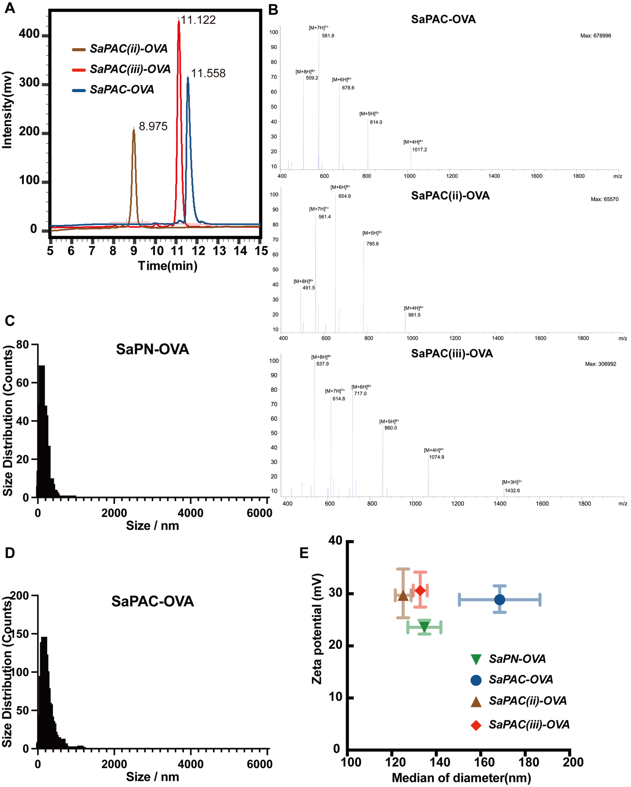
Figure S4. Physicochemical characterization of SaPAC-OVA variants. (A) Reversed-phase HPLC profiles of SaPAC-OVA, SaPAC(ii)-OVA, and SaPAC(iii)-OVA. (B) High-resolution mass spectra confirming SaPAC-OVA, SaPAC(ii)-OVA, and SaPAC(iii)-OVA. (C,D) Representative NTA size distributions of SaPN-OVA and SaPAC-OVA, respectively. (E) ZetaView/NTA hydrodynamic diameter and zeta-potential measurements for peptide constructs and vaccine nanoparticles. Full numerical size, zeta-potential, buffer-condition, and independent-batch data are summarized in Table S2.

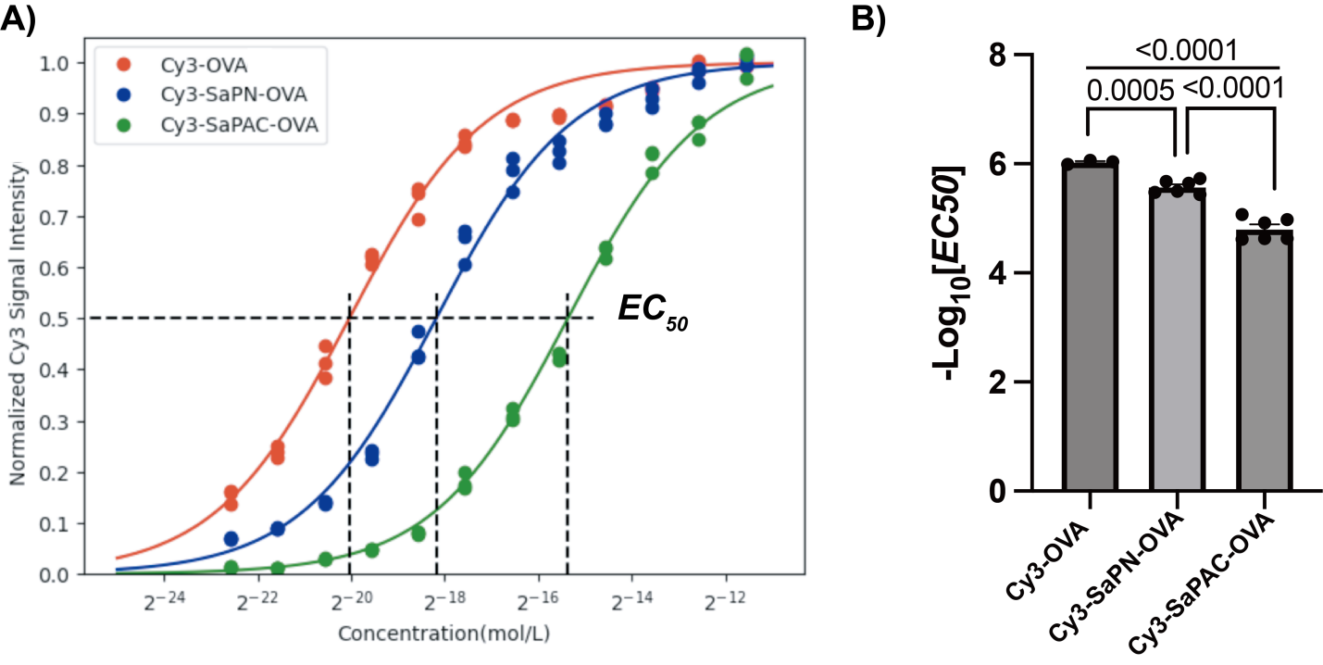

Figure S5 Normalization of Cy3 signal to concentration of Cy3-SaPAC-OVA, Cy3-SaPN-OVA and Cy3-OVA. Normalized percent fluorescence of Cy3-OVA, Cy3-SaPN-OVA and Cy3-SaPAC-OVA in different concentrations in 1xPBS measured by biofluorescent IVIS. The data were fitted by a solid line using SciPy in Python 3.8 A) Calculated effective concentration with half of maximum fluorescence (EC50) for different peptide or peptide-adjuvant conjugates, Cy3-OVA, Cy3-SaPN-OVA and Cy3-SaPAC-OVA respectively. B) EC50 for each peptide or vaccine were compared in a bar graph.

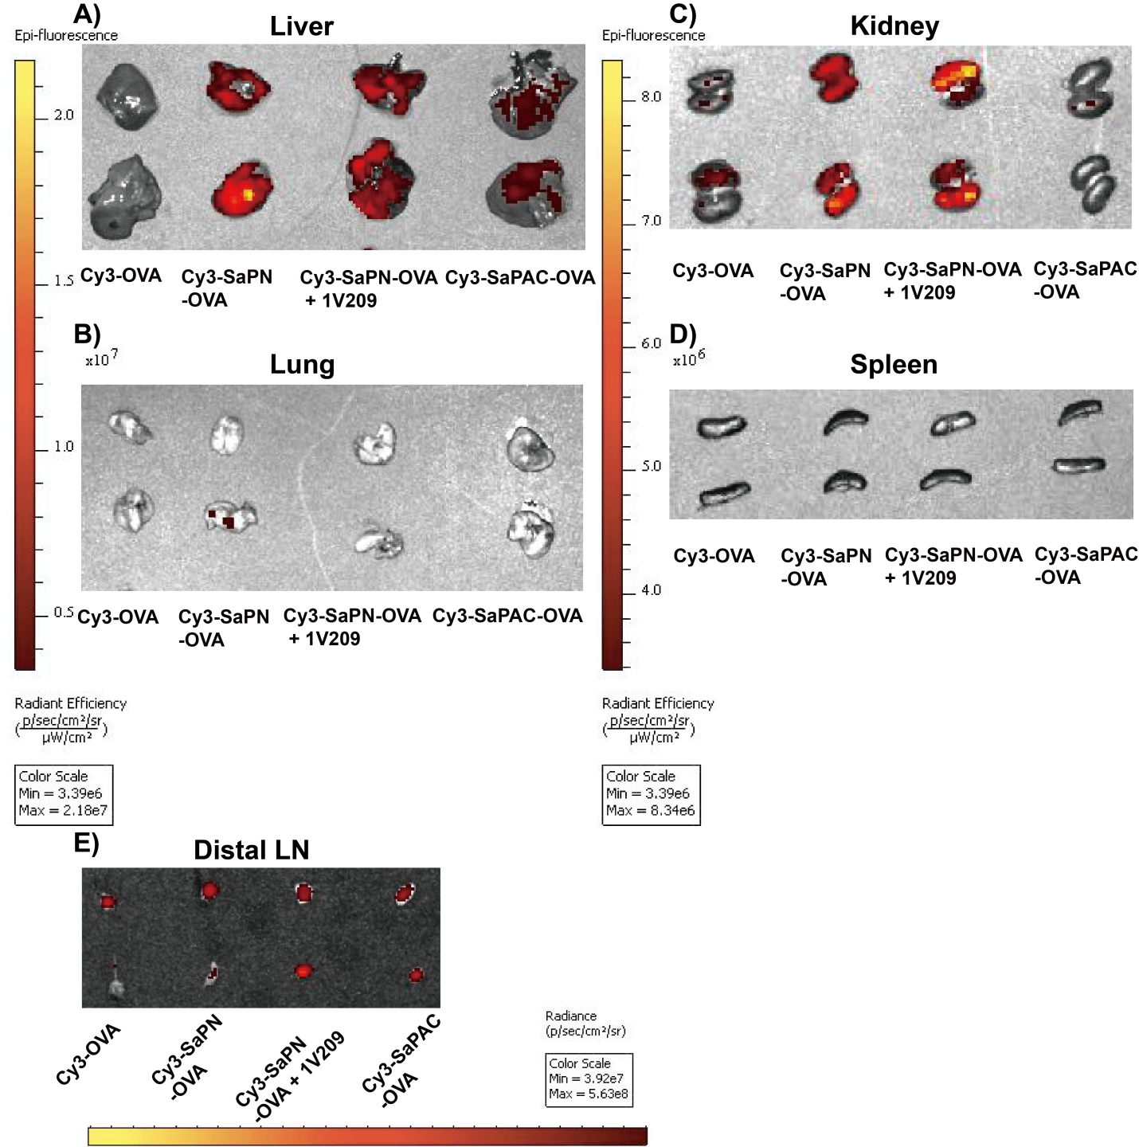

Figure S6. Biodistribution of different vaccine formulations 24 h after subcutaneous vaccination. Molar-equivalent Cy3-OVA, Cy3-SaPN-OVA, Cy3-SaPN-OVA + 1V209, or Cy3-SaPAC-OVA were injected into mice (n = 4/group). SaPAC-OVA contains three covalently linked 1V209 moieties; the Cy3-SaPN-OVA + 1V209 group received three molar equivalents of unconjugated 1V209. IVIS fluorescence was measured in (A) liver, (B) lung, (C) kidney, (D) spleen, and (E) distal lymph nodes.

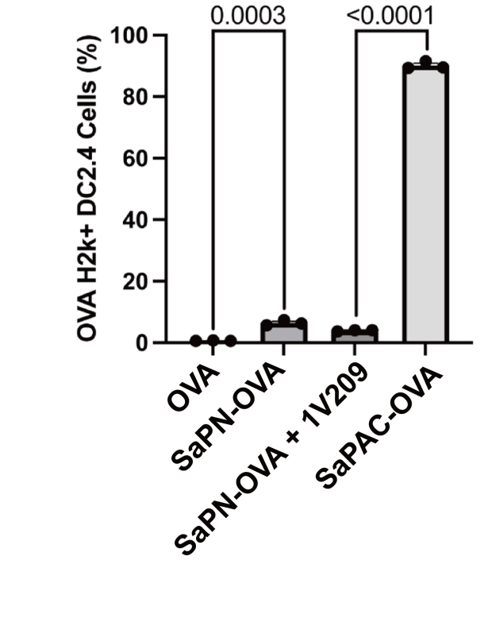
Figure S7. DC2.4 cell line presentation after 24 h co-culture with various vaccines or peptides

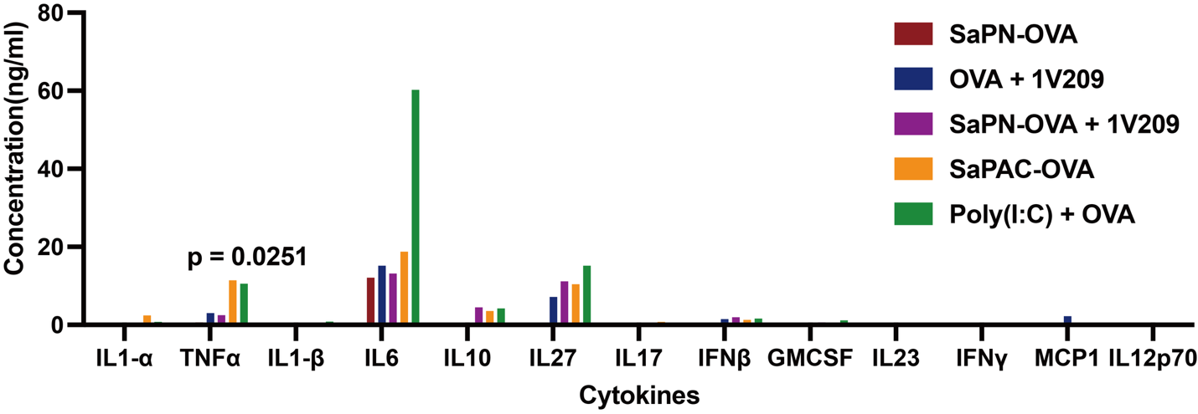
Figure S8. Cytokine profiling of supernatants from vaccinated mouse splenocytes restimulated with OVA. TNF-alpha concentration was increased in the SaPAC group (P = 0.0251 versus WT).

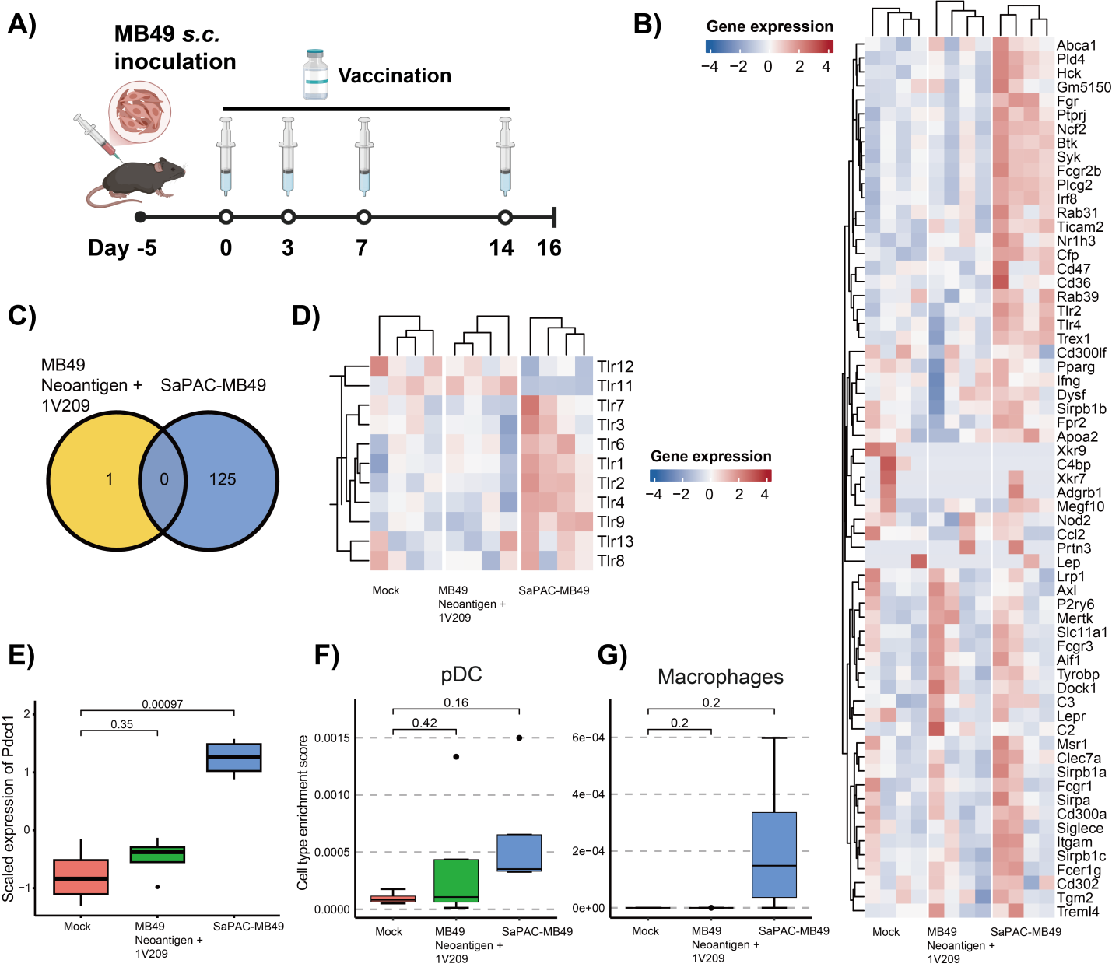
Figure S9. Transcriptomic analysis of innate immune activation in MB49 tumor-draining lymph nodes after SaPAC-MB49 treatment. (A) Treatment timeline. (B) Heatmap of phagocytosis-related genes. (C) Venn diagram of significantly upregulated genes. (D) GO enrichment analysis. (E) PD-1 expression. (F,G) ssGSEA scores for plasmacytoid dendritic cells and macrophages. Data are mean +/- SEM; significance was assessed by unpaired two-tailed Student's t-test.

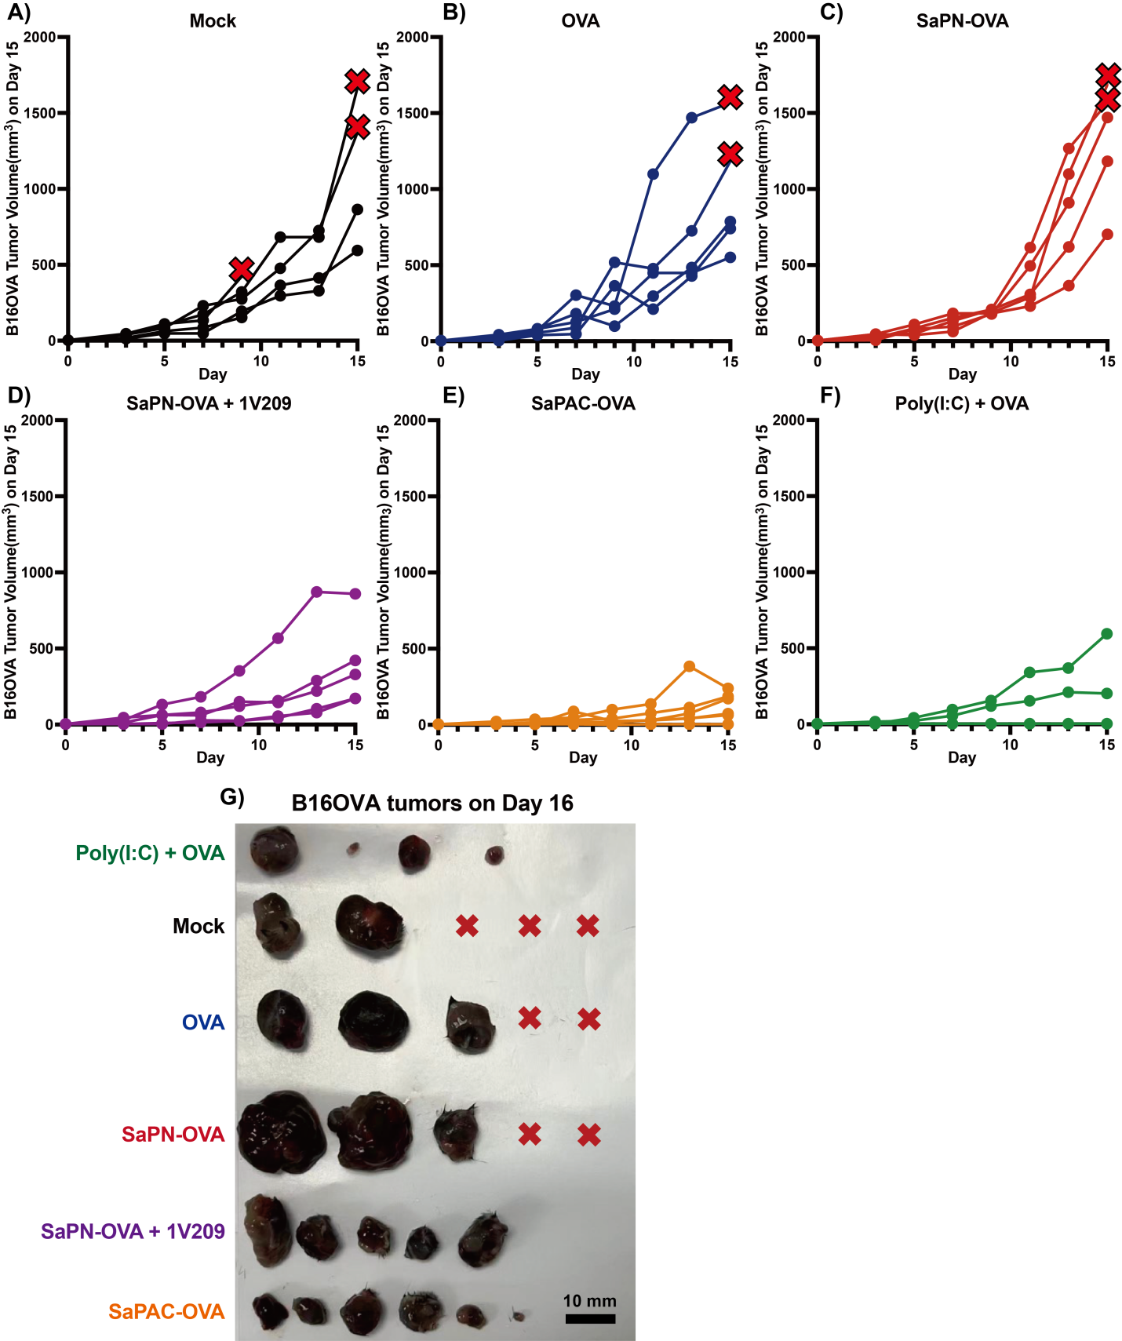
Figure S10. Individual B16-OVA tumor growth curves and endpoint tumors from Figure 5A-F. (G) Red crosses indicate mice that died before endpoint.

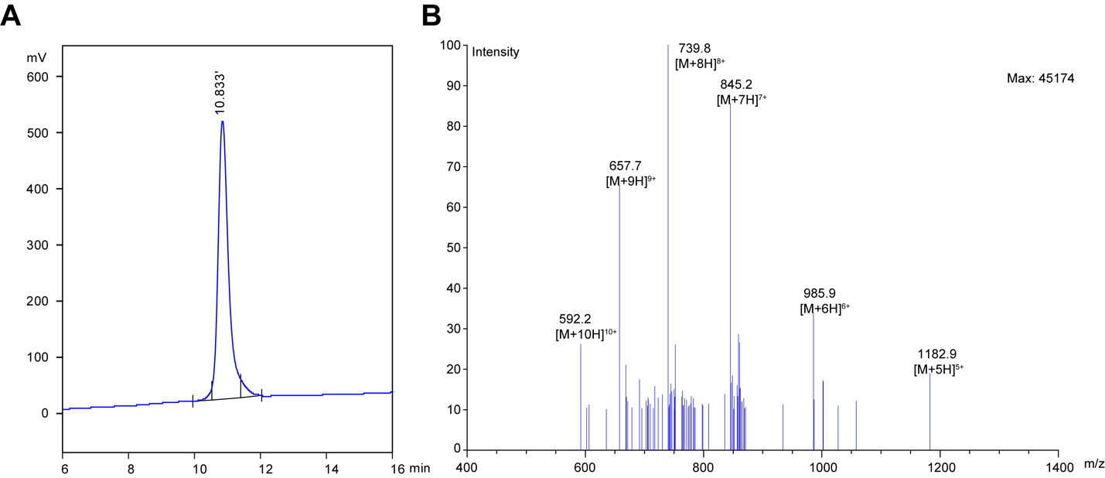
Figure S11 Characterization for SaPAC-MB49. A) Mass spectrometry for SaPAC-MB49. B) High-resolution liquid chromatography for SaPAC-MB49.
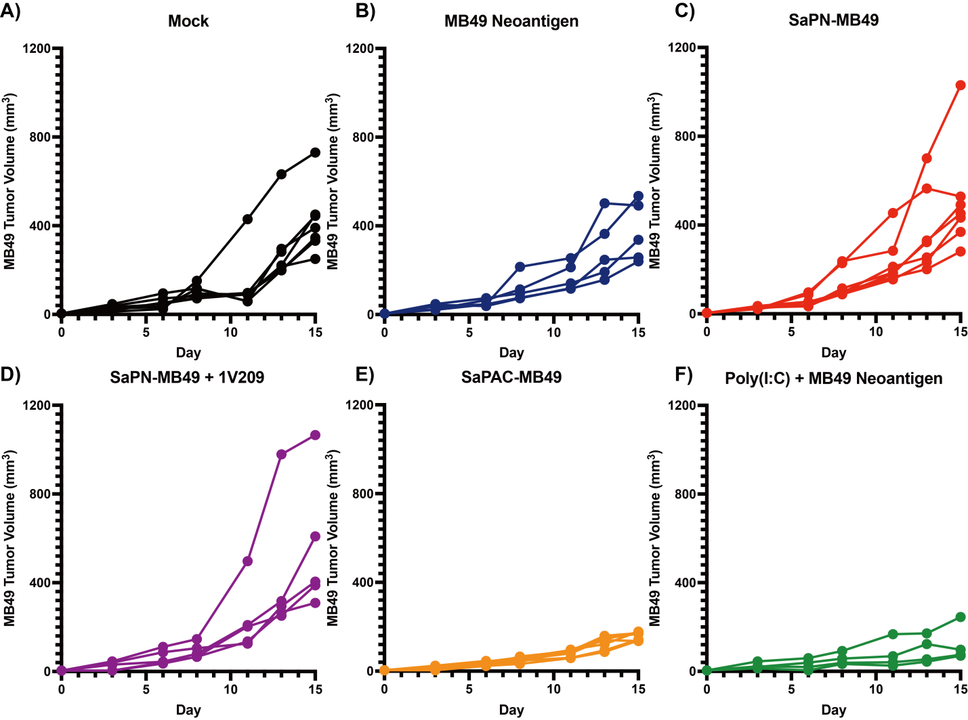
Figure S12. Individual MB49 tumor growth curves from Figure 5G-I.
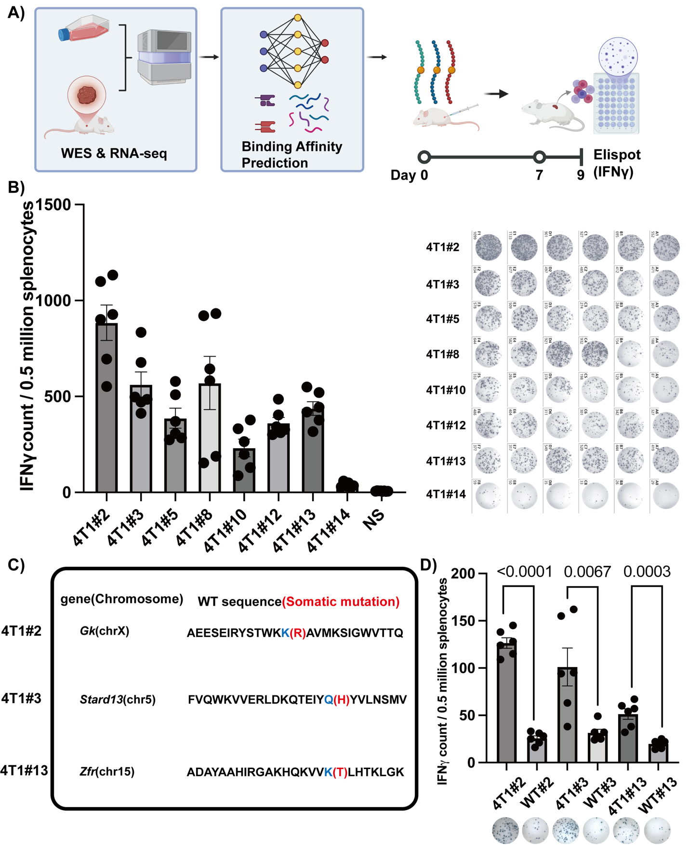
Figure S13. 4T1 neoantigen screening and selection. (A) Neoantigen screening pipeline using sequencing, somatic mutation calling, NetMHCpan ranking, and peptide synthesis. (B) IFN-gamma ELISPOT quantification after candidate peptide vaccination with Poly(I:C). (C) Selected neoantigens 4T1#2, 4T1#3, and 4T1#13 with mutation positions and sequences. (D) Wild-type counterpart peptide vaccination showing no significant cross-reactive immunogenicity. Statistical significance was assessed by an unpaired two-tailed Student's t-test.

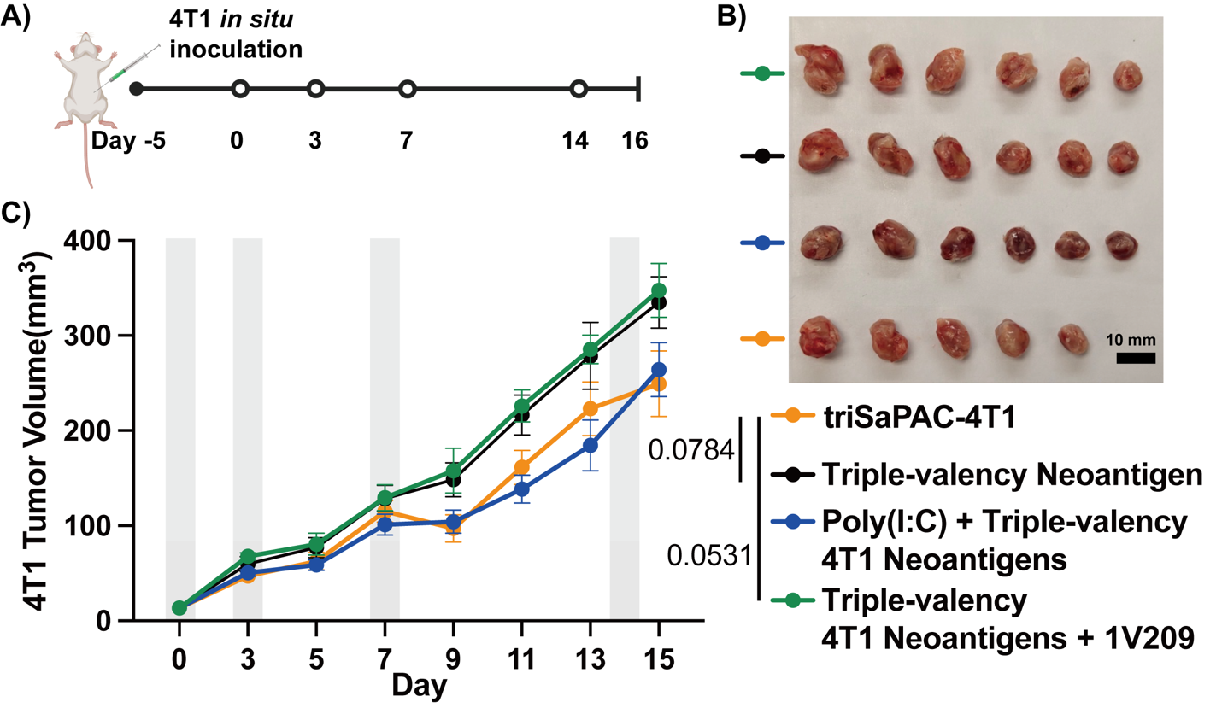
Figure S14. Therapeutic evaluation of triSaPAC-4T1 monotherapy in the orthotopic 4T1 model. Treatment timeline and vaccination schematic for 4T1 neoantigen mixture, triSaPAC-4T1, 4T1 neoantigen + Poly(I:C), and 4T1 neoantigen + 1V209. Tumor volumes were recorded every 2-3 days until day 16. Significance was assessed by unpaired two-tailed Student's t-test.

